NSCI 20100 Neuroscience Laboratory

Electro-oculogram Recordings

BSLC 322, January 10/12, 2018

***Update Save/Load in CT to be object based.***

**Goals:**

**Reading:**

**Safety:** Once the EOG electrodes are installed, keep the leads protected and away from water and electrical sources until they are inserted into the isolation unit. No personal protective equipment (PPE) is required or recommended.

**Data:** You will collect eye position traces for saccades of four different sizes. You should collect data from both students in each pair (complete data collection from the first before beginning the second).

**Clean up:** When you have finished, you should quit Matlab, collect any data files from the lab machine and discard your files on the lab machine. You do not need to log out, reboot or shutdown the computer.

EOG electrodes should be gentle cleaned to remove electrolyte gel. **PROCEDURES**

**Lab Report:** Lab reports should be prepared following the general instructions found on the course [Canvas site](https://canvas.uchicago.edu/courses/11181/assignments/syllabus). In preparing your report, you should consider the following:

*Introduction:* What are saccadic eye movements? What is the biological basis of the EOG?

*Methods:* Describe the procedures that were used. If your average velocity traces show movements before the onset of the saccade, explain why.

*Results:* Include a figure showing your data in your report. How are your saccades of different sizes related (same duration? same constant acceleration? same constant acceleration to a limiting speed?). Are the results consistent between subjects? Does reaction time differ between stimulus step sizes?

*Discussion:* Given that load on the eye muscles is constant (one eyeball), what can you infer about the forces generated by the eye muscles during saccades of different sizes. What might affect whether reaction time differs for different stimulus step sizes?

**Laboratory Procedures**

You will use a Matlab application to collect your data. The necessary software is installed and configured on each of the lab’s computers. Use the following procedures to run the software.

1) Log into the “labuser” account. There is no password for this account: Do not enter anything in the password field.

2) Launch Matlab by clicking on the Matlab icon in the dock at the bottom of the display. (Matlab might have a date appended to its name, such as “Matlab_2015b”.)

3) When it launches, Matlab will display a large, multi-paneled window. Launch the Contrast Threshold application by entering “EOG” in the Matlab “Command Window” at the bottom of the Matlab window.

4) The EOG application will take several seconds to launch, and it will display warnings in the Matlab “Command Window” and the display window that is created on the screen. You can safely ignore all these warnings. Once the EOG application has finished launched, you will see two new windows, which are described below.

5) When you have finished collecting and saving your data, you can terminate the EOG application by either 1) closing the EOG control panel window using its close button (red button in the upper left corner), 2) closing the Matlab window using its close button, or 3) making Matlab quit using Quit in the File Menu (or the keyboard equivalent, command-Q). In any case, you will be asked whether you are sure you want to quit. All unsaved data will be lost when you quit.

../../Screen%20Shot%202017-12-11%20at%2018.30.33.png

**Running the EOG Task**

The stimulus display will appear as a long, thin dark gray window at the bottom of the monitor. The control/display panel will appear above and to the right. You should familiarize yourself with the controls and displays and run some test trials before you start collecting data you plan to use. You can clear any test data before you start any serious data collection.

The task involves little more than following the small white dot with your eyes. At regular intervals, the white dot will jump left or right at random by 4°, 8°, 12° or 16°. You should simply do your best to keep your gaze on the dot. It is not important that you have a fast reaction time, but you should shift your gaze to follow the dot shortly after it moves.

Before collecting data, you must adjust the task settings. You must enter the **Viewing Distance**. To set the viewing distance, find a comfortable viewing position and measure the approximate distance from your eyes to the screen. This should generally be 50 to 75 cm. You must enter this value before data collection to ensure that the stimulus steps are calibrated.

You should adjust the **Filter Width** so that you can reliably see the smallest (4°) saccades. The eye position data are smoothed with a boxcar filter, the width of which is set by this entry. Eye positions are sampled every 1 ms, so a value of 1 ms corresponds to no filtering. Too little filtering will leave you with noisy data that will require you to collect many samples. Too much filtering will remove high frequencies and distort the dynamics of the eye movements. You should not change this setting after you start collecting your date.

Once the filter width is set, you should adjust the **Saccade Threshold** so that you reliably detect most of the 4° saccades without allowing fluctuations in the noise to be classified as saccades. It is better to miss some saccades than to include spurious signal fluctuations as saccade. The program detects the start and end of each saccade using a speed threshold. The threshold is visible as horizontal lines in the most recent velocity trace (plot 3). The threshold is applied to the filtered traces. Five consecutive values above the threshold are counted as the start of a saccade. After a saccade starts, the first five consecutive values below the threshold are counted as the end of the saccade.

**Breaks**: You should take frequent breaks, but you should not leave the task running when you pause. You should be tracking the spot with your eyes whenever the task is running. You can use the **Start/Stop** button to toggle the task run state. For convenience, you can also use the space bar to toggle the run state if the control panel is front-most. This allows you to pause the task without looking at the control panel.

**Controlling the EOG Task**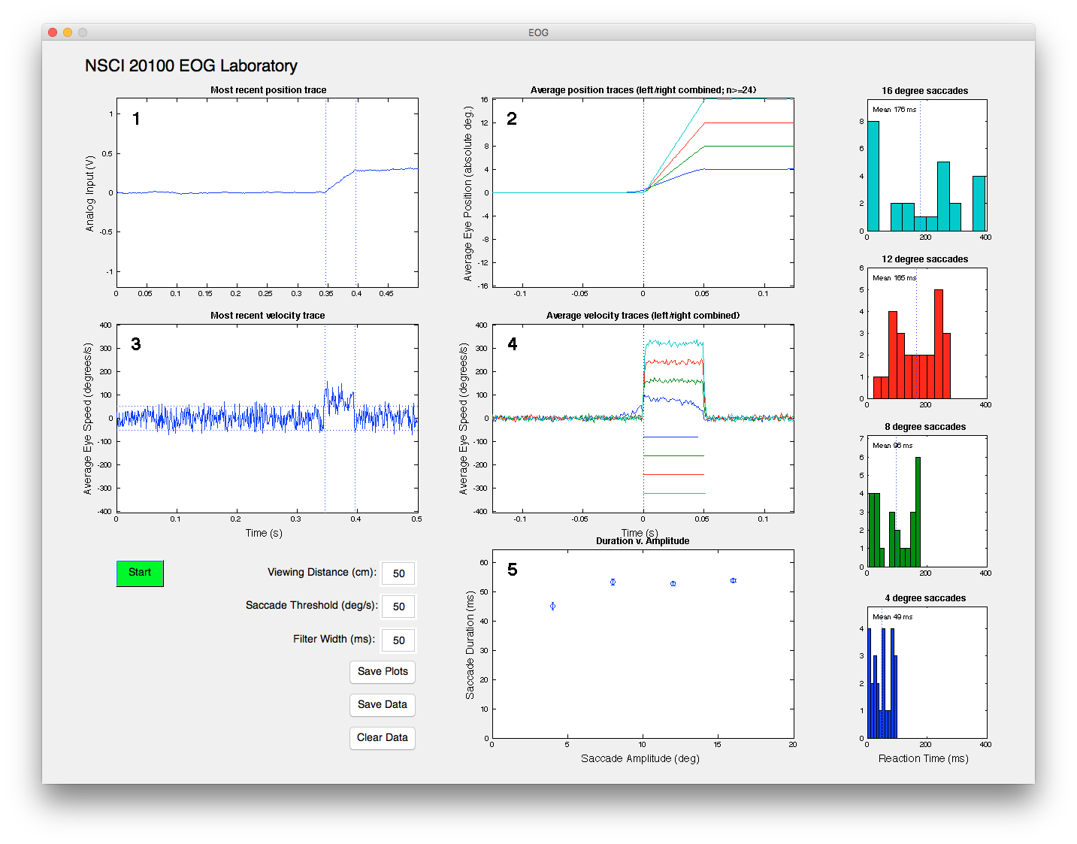

The following controls are found at the bottom left of the Control Panel.

**Start (Stop):** Toggle whether the task is running. You can also use the space bar when the control window is front-most.

**Viewing Distance (cm):** The distance from your eyes to the screen. This value must be set before data collection to ensure that your position and speed measures are properly calibrated.

**Filter Width (ms):** The width of the boxcar filter that smooths the eye position traces (and thereby the eye velocity traces).

**Saccade Threshold (deg/s):** The program detects the start and end of each saccade using a speed threshold. You can adjust that threshold here. The threshold is applied to the filtered traces. If your filtered trace is noisy, you will need to set the threshold higher to avoid spurious detections. If your filtered traces are less noisy, you can set the threshold lower to get more precise measurements of the saccade dynamics.

The following displays are plotted in the control/display panel:

**1) Most recent position trace:** The most recent position trace is displayed. The difference between the two EOG electrodes is plotted as a function of time. Depending on which electrode is connected to the positive amplifier input, left and right eye positions will correspond to either up and down, or else down and up. If a saccade is detected, its duration (above saccade speed threshold) will be marked by vertical lines. Each trace is offset so that the earliest portion of the trace lies at y = 0 V. In this and all other panels, colors correspond to the size of the target step.

**2) Average position traces:** A separate average is computed for each of the four target step sizes, but leftward and rightward steps of the same size are combined by flipping one direction before averaging. Before averaging, individual traces are offset so that the pre-saccadic period lies at y = 0 V, and the start of the saccade is aligned at t = 0 s. The y axis is scaled in degrees by assuming that the average post-saccadic position is offset from 0 by the size of the target step. If no saccade is detected on a given trial, that trace will not be included in the average.

**3) Most recent velocity trace:** The most recent velocity trace is displayed. This curve is the derivative of the most recent position trace plotted in panel 1. Calibration is in V/s until enough traces have been collected to establish a voltage-to-position calibration, after which it is plotted in units of deg/s. Horizontal lines mark the saccade threshold for leftward and rightward saccades. Vertical lines mark the duration of any detected saccade.

**4) Average velocity traces:** A separate average is computed for each of the four target step sizes, but leftward and rightward steps of the same size are combined by flipping one direction before averaging. These curves are based on the derivatives of the traces that were used to compute the average position traces in panel 2. Colored lines below the traces mark the period where the average velocity is above the saccade threshold.

**5) Saccade duration versus amplitude:** Saccade duration in milliseconds is plotted as a function of the four saccade amplitudes.

The column of plots at the right edge of the display panel plots saccadic reaction times for the different step sizes. There is one entry for every trial on which a saccade was detected. The value is the delay between the step occurrence and the onset of the saccade.